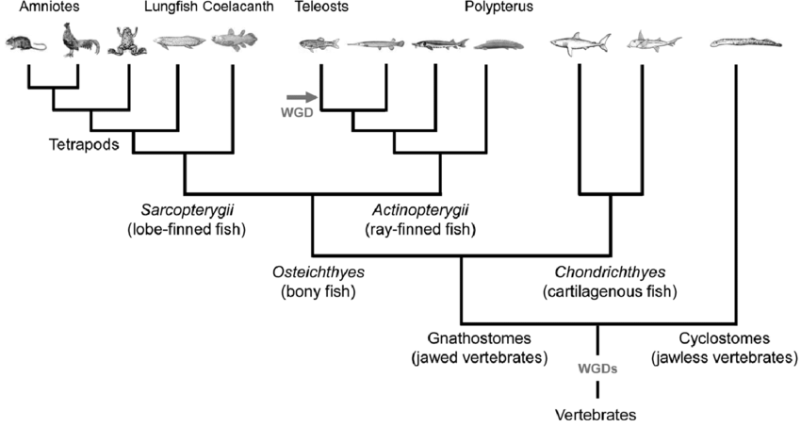

Phylogenetic tree of vertebrates. A simplified phylogenetic tree focusing on the evolution of Osteichthyes (bony fish). Osteichthyes is divided into two categories: Sarcopterygii (lobe-finned fish) that contains tetrapods, and Actinopterygii (ray-finned fish) that contains teleosts. Based on recent findings, it is hypothesized that two rounds of whole genome duplication (WGD) occurred before the gnathostomes-cyclostomes split. The teleost lineage went through an additional WGD.

